Minutes of Brailes Parish Council Planning Committee on Saturday 16th April 2016, commencing outside the rear of The Old Bakery, Friars Lane at 9.30am

Present: Apologies:
Tony Ashall (Chairman) Steven Kaack
John Greaves
Michael Rosenthal
Tony de Maillet
Maggie Witherick

1. Disclosure of Interests
Councillors are reminded that they must act solely in the public interest and should not improperly confer an advantage or disadvantage on any person or act to gain financial or other material benefits for themselves, their family, a friend or close associate.

To receive any written request for dispensation or discloseable pecuniary interests.

2. 16/00902/FUL - Land at the rear of The Old Bakery, Friars Lane, Lower Brailes. Construction of two detached dwellings and associated garages.
Unanimous vote to object on the following planning grounds:
-previous flooding (see pictures below of 1997 flood)
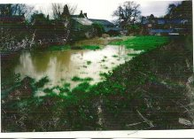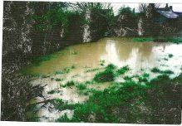
-the overbearing height of the two storey development compared to the one and a half storey houses each side
-part of the proposal is backlands development, not respecting the characteristic linear development in Brailes noted in their own Planning/Design and Access Statement
-only a single garage with parking in front of it for 3 bedroom house
-increase in traffic in a cul-de-sac

3. 16/00914/LBC - Stone Croft, Upper Brailes. Rebuilding of water well at front of house using existing stone and at wider diameter to sit above the brick wall of well chamber, incorporating a metal grille within the structure.
Unanimous vote of no objection

4. 16/00899/FUL - Long Barn House, Holloway Hill, Lower Brailes. Demolition of existing dwelling and erection of replacement dwelling (including creation of new access onto private driveway already approved and extant under 00/00894/FUL) with detached garage/ancillary living space.
Unanimous vote to object on the following planning grounds:
-Detrimental impact on the only AONB in Warwickshire
-The design and architectural type is inappropriate for this area and for the Cotswolds AONB
- The scale of the three storey building is out of proportion in this sensitive area
- Due to the position and size of the proposed new dwelling this proposal would represent harm to the visual amenity and the intrinsic character and beauty of the countryside
- The proposal would significantly alter the rural character of the area and the visual amenity of the Cotswolds AONB.

Meeting finished at 10.45am

