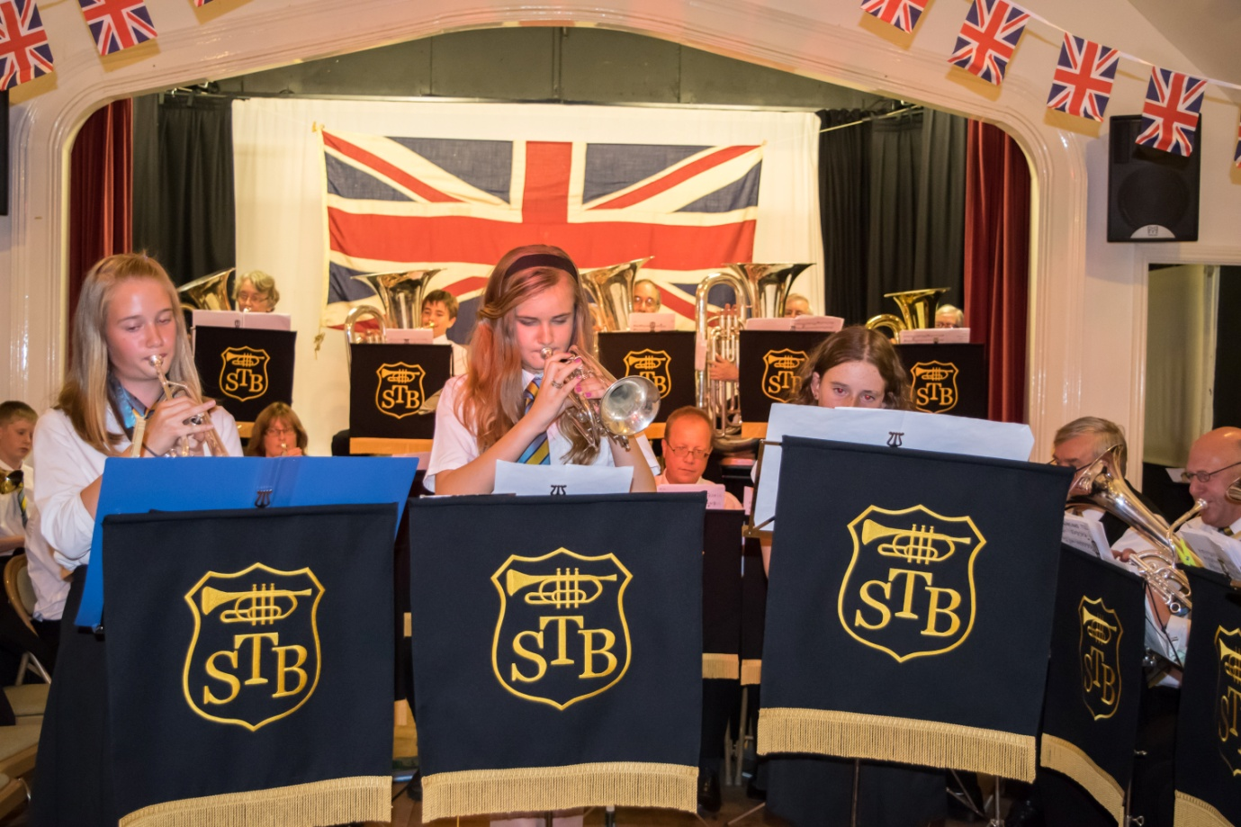
Stour Concert Brass
Present The Band Is Back In Brailes
A Charity Concert at
St George’s Church Brailes
Saturday April 16th7.30 p.m.
Admission Free
Net Proceeds To Local Charities

